Laboratory 5  
ESP32 IDE Code  
The ESP32 uses an MPU6500 IMU sensor to measure the orientation of an object. It continuously checks the measured tilt angle against a 30-degree threshold, triggering a buzzer alarm if the object exceeds this threshold. The measured tilt angle is sent over WiFi to an MQTT broker, which acts as a communication channel between the ESP32 and other systems.

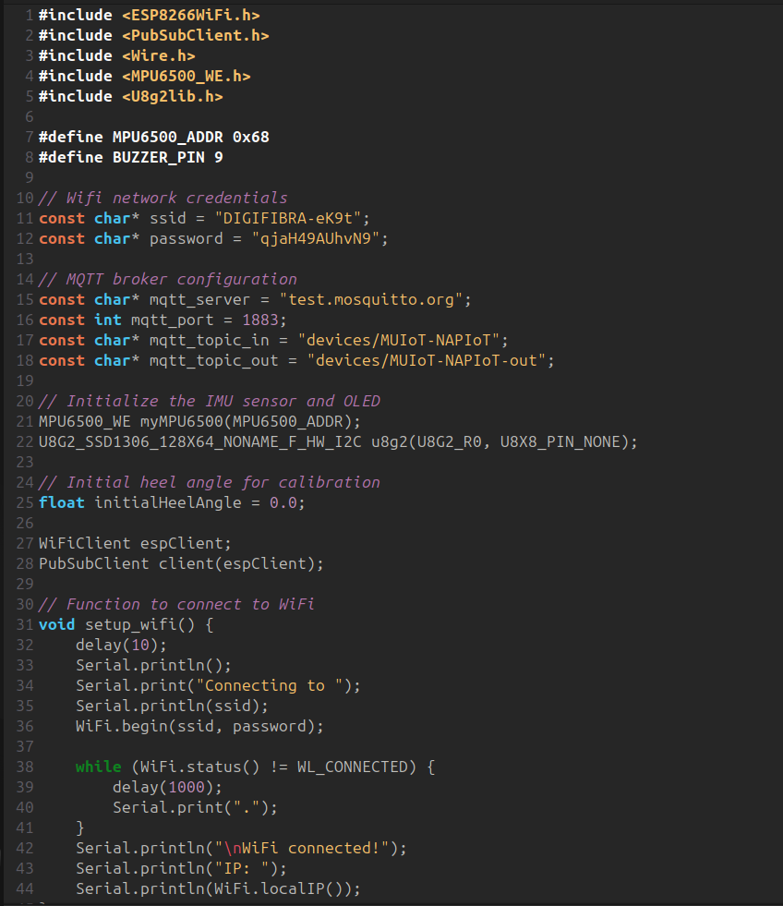

FlowFuse  
FlowFuse processes the tilt data received from the MQTT broker and applies logic to determine if the threshold is exceeded. A function node formats the data into messages like "Alarm: 30° threshold reached. Tilt angle: X°" for conditions exceeding the threshold, or "Tilt angle measured: X°" for normal readings. Throttling techniques prevent excessive notifications, ensuring data is forwarded more slowly to the dashboard. At the same time, the dashboard is showing real-time payload, in this case, the tilt angle.

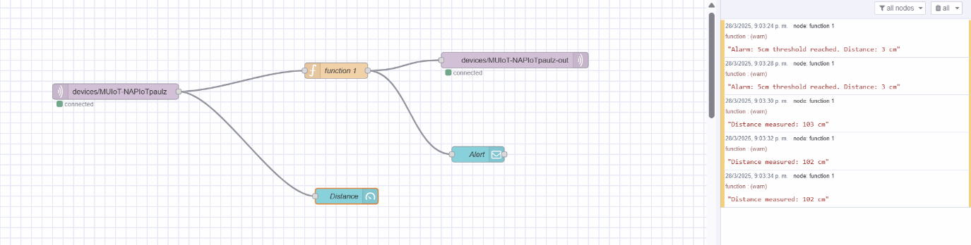

Dashboard 2.0  
The dashboard provides a user-friendly interface to visualize the tilt angle data in real-time. A gauge displays the tilt angle in degrees, while notifications pop up with alert messages like "Alarm: 30° threshold reached. Tilt angle: X°" whenever the threshold is breached. This allows users to monitor the sensor readings and take action when needed.